AWS Cloud project
This project implements a disaster recovery solution for Nain Softech to ensure continuous business operations during system outages. It uses Amazon EC2 to maintain backup instances in a secondary region and Amazon S3 to securely store critical data backups. AWS Backup provides centralized and automated backup management, while Amazon Route 53 enables DNS failover to redirect traffic to the backup site during disruptions. The setup ensures high availability, data durability, and minimal downtime for uninterrupted service continuity.

Steps:
- Create an confiqure primary EC2 instance
- Create an S3 bucket
- Create an enable AWS Backup.
- Create and configure the secondary EC2 instance
- Configure Route 53 DNS Failover server and test the failover server.

EC2 instance:
- Now Check the Region Zone in Mumbai ap-South-1.
- Choose EC2 -> select Instance is open and click “Launch Instances”.
- Type the Name of the serve in Name tab(Linux_Primary_server).
- Choose the “Amazon Linux AWS” in Application and OS tab
- Choose free tier option in Amazon Machine Image
- Choose “t3.micro” for free tier eligible in Instance type tab
- Create a new key pair in key pair login tab
- Create key pair dialog box will be open
- Type the key pair name(Linux_serverkey)
- Choose “RSA” in key pair type.
- Select .ppk file format in private key file format then click “create key pair”
- Linux_serverkey.ppy file download automatilcally.
- Select “Allow SSH traffic from” in network settings tab.
- Select “Allow HTTP traffic through internet” option
- In windows server need minimum 15GB in Configure storage tab.
- Under user data – optional tab below the code copy and paste and change you website name

#!/bin/bash
yum install -y httpd
systemctl start httpd
systemctl enable httpd
echo '<h1>This is Nainsoftech Primary Instance</h1>' >/var/www/html/index.html
- Select Launch instance

S3 Bucket
- Now Check the Region Zone in Mumbai ap-South-1.
- Type S3 in search Box and Click create bucket
- Choose AWS Region ap-south-1
- Type the name of bucket is nainprimarybackup
- Select the checkbox for Block all public Access.
- Choose Enable the bucket version
- Choose SSE-SE or SSE-KMS for Encryption Type.
- Select Enable the bucket key.
- Click Create Bucket button.

AWS Backup Plan
- Now Check the Region Zone in Mumbai ap-South-1.
- Type AWS Backup Plan in search Box and choose it and click create backup plan for EC2 instance.
- Select Build a new plan from backup plan options
- Type Nain-BackupPlan from backup plan name.
- Inside Backup Rule tab
  - Frequency : Daily
  - Backup window : Default
  - Lifecycle : move to cold storage after 30 day
- Now Click Create Plan.
- Now Assign resource Page Open. Type the Primary_Resource in Resource assignment name
- Now go to Resource Selection tab, Choose Include specific Resource Type.
- Select EC2 in specific Resource Type tab, the select the EC2 instance Linux_Primary_server. Click Assign resources Button
- Again Click Create backup plan for S3.
- Select Build a new plan from backup plan options
- Type Nain-S3-Backup from backup plan name.
- Inside Backup Rule tab
  - Frequency : Daily
  - Backup window : Default
  - Lifecycle : move to cold storage after 30 day
- Now Click Create Plan.
- Now Assign resource Page Open. Type the Nain_S3_Resource in Resource assignment name
- Now go to Resource Selection tab, Choose Include specific Resource Type.
- Select S3 in specific Resource Type tab, the select the S3 Nain_Primary_Backup. Click Assign resources Button

EC2 Instance
- Now Change the Region Zone in Singapore ap-Southeast-1.
- Choose EC2 -> select Instance is open and click “Launch Instances”.
- Type the Name of the serve in Name tab(Linux_Sec_Server).
- Choose the “Amazon Linux AWS” in Application and OS tab
- Choose free tier option in Amazon Machine Image
- Choose “t3.micro” for free tier eligible in Instance type tab
- Create a new key pair in key pair login tab
- Create key pair dialog box will be open
- Type the key pair name(Linux_serverkey)
- Choose “RSA” in key pair type.
- Select .ppk file format in private key file format then click “create key pair”
- Linux_serverkey.ppy file download automatilcally.
- Select “Allow SSH traffic from” in network settings tab.
- Select “Allow HTTP traffic through internet” option
- In windows server need minimum 15GB in Configure storage tab.
- Under user data – optional tab below the code copy and paste and change you website name

#!/bin/bash
yum install -y httpd
systemctl start httpd
systemctl enable httpd
echo '<h1>This is Nainsoftech Secondary Instance</h1>' >/var/www/html/index.html

- Select Launch instance

Route 53
- Type Route 53 in search box, and select Hosted Zones.
- Click Create hosted zone.
- Type naintech.co.in in Domain name and click Create hosted zone button
- Click Create Health Check.
- Type PrimaryHealthCheck in Name
- Choose EndPoint in Resource
- Choose IP address in Specify endpoint by
- Copy the Primary EC2 Instance IPv4 address and paste it in IP Address field
- Click Create Health Check button
- Click Create Health Check.
- Type SecondaryHealthCheck in Name
- Choose EndPoint in Resource
- Choose IP address in Specify endpoint by
- Copy the Secondary EC2 Instance IPv4 address and paste it in IP Address field
- Click Create Health Check button
- Next go to naintech.co.in Host zone.
- Now click create record button.
- Select “A-Routes traffic to a IPV4 address for some aws resources” in Record Type.
- Copy the Public IPV4 address in Primary server EC2 instance and paste it value field
- Choose the Failover in Routing Policy and click create records
- Choose Primary in Failover Record type
- Choose the PrimaryHealthcheck in Health check status
- Type REC001 in RecordID.
- Now click create record button.
- Now click create record button another time .
- Select “A-Routes traffic to a IPV4 address for some aws resources” in Record Type.
- Copy the Public IPV4 address in Secondary server EC2 instance and paste it value field
- Choose the Failover in Routing Policy and click create records
- Choose Secondary in Failover Record type
- Choose the SecondaryHealthcheck in Health check status
- Type REC002 in RecordID.
- Now click create record button.
- Now Go to health check and check the both the instance is healthy
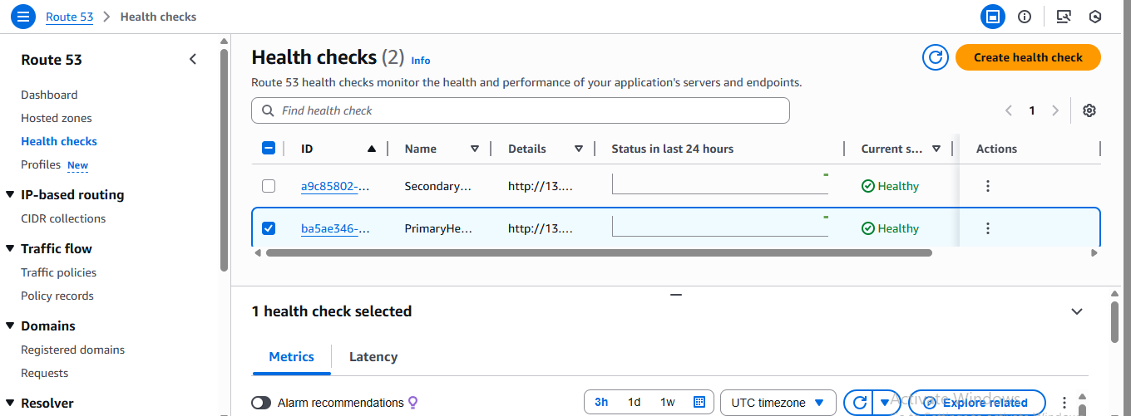

- Now naintech.co.in run the browser. Now primary instance output will come.

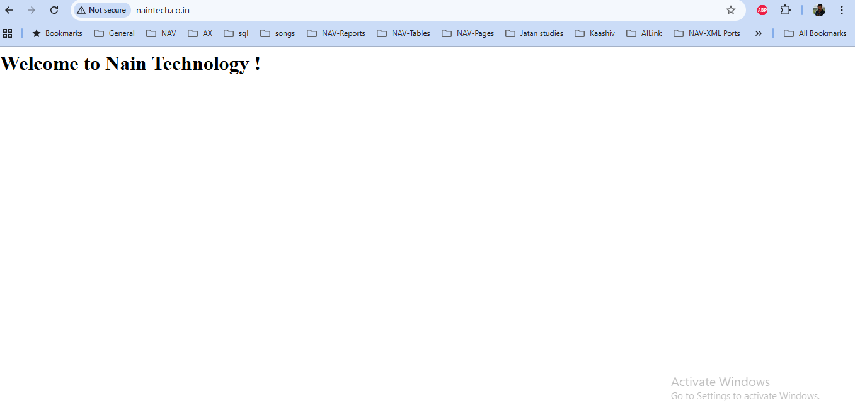

- Now stop the Primary EC2 instance.
- Now go to the health check and check the health check status. Now Primary instance is unhealthy, and Secondary instance is healthy.
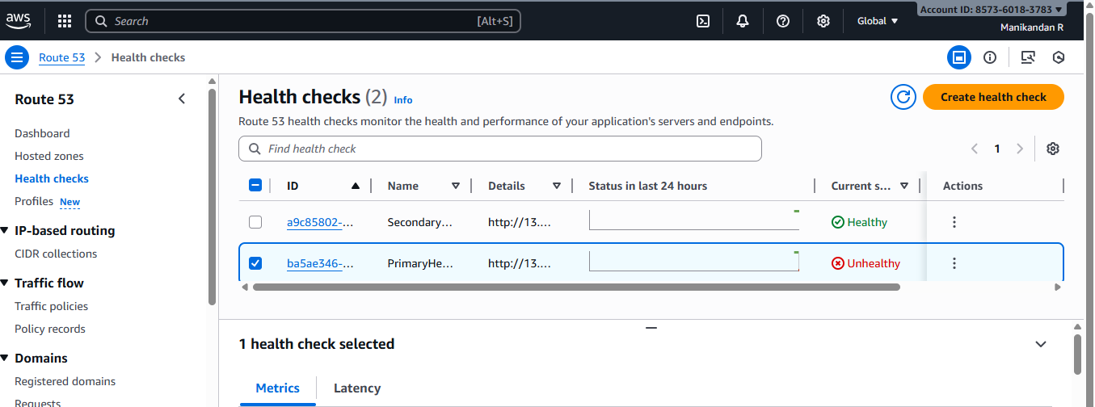
- Now naintech.co.in run the browser. Now Secondary EC2 instance output will come.
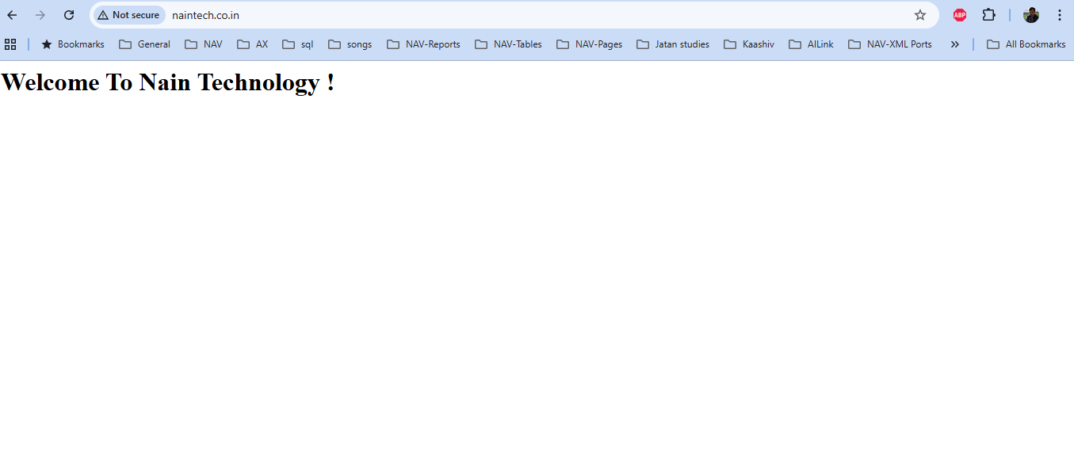

- Now stop the both primary and secondary instance.
- Now go to the health check and check the health check status. Now both the instance is unhealthy.
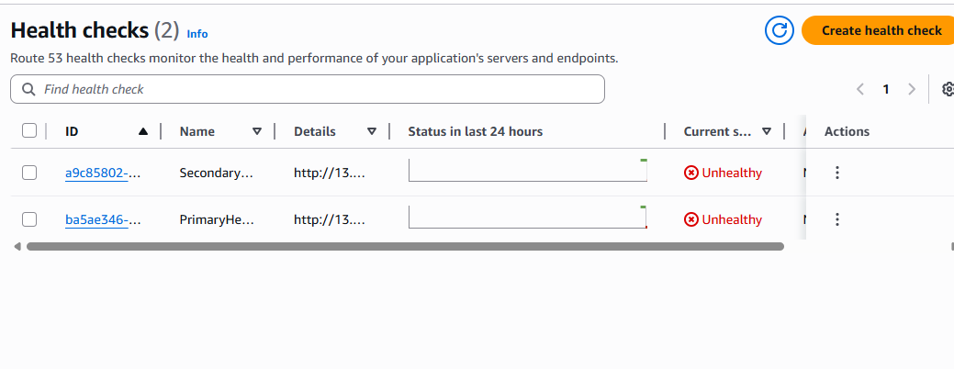
- Now naintech.co.in run the browser. Now website is not showing.
